**Duck Feeder**

**Components and supplies:**

1. 2x Arduino UNO
2. L298N H-bridge
3. 2x HC-05 Bluetooth module
4. 1x push button
5. 1x 1k ohm resistor
6. 1x 2k ohm resistor
7. 1x 10k ohm resistor
8. 1x motor
9. 12V battery source
10. 5V battery

**Software/Apps:**

Arduino IDE

**How it works:**

To Bluetooth modules are paired together, and configured as master and slave. The master is connected with the push button and depending on whether the button is on or off, it sends the appropriate data to the slave. The slave is connected to our main project and the motor runs whenever the switch is closed. When both parts are switched on (battery is connected) the Bluetooth modules with pair automatically (they are bound initially). On closing the switch the motor will take one turn, however the switch must be opened to stop the motor turning again.

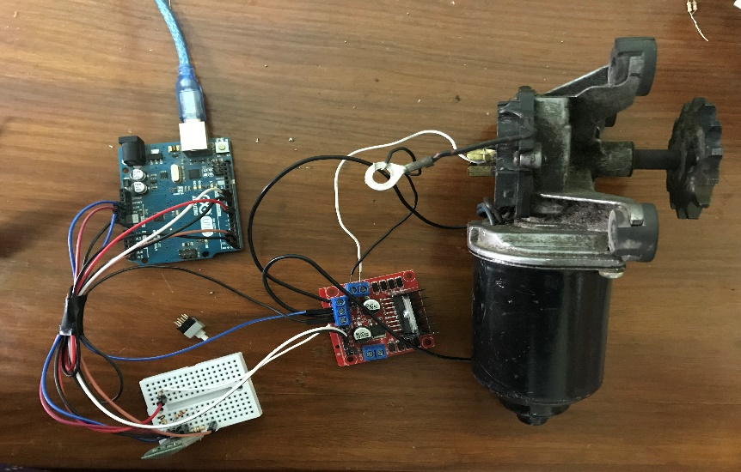

**Bluetooth Configuration:**

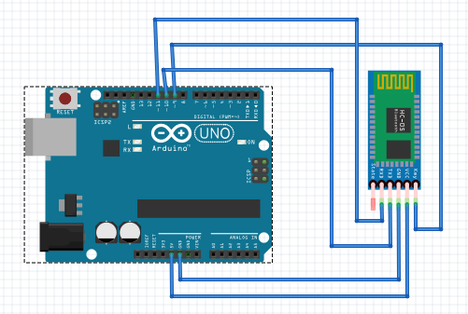

To bind the two modules we must first configure one as slave and the other as master. Connect one of the modules as shown above and upload the following code on the Arduino:

#include <SoftwareSerial.h>

SoftwareSerial mySerial(10, 11); // RX, TX

void setup() {

Serial.begin(9600);

pinMode(9,OUTPUT); digitalWrite(9,HIGH);

Serial.println("Enter AT commands:");

mySerial.begin(38400);

}

void loop()

{

if (mySerial.available())

Serial.write(mySerial.read());

if (Serial.available())

mySerial.write(Serial.read());

}

After the code is uploaded, remove the VCC pin to the Bluetooth modules, hold down the reset button on the module, and reconnect the VCC pin while still holding down the button. The led on the module must now be blinking once in two seconds which means the module has entered AT mode.

Open serial monitor and set baud rate to 9600, and change No Line Ending to Both NL and CR.

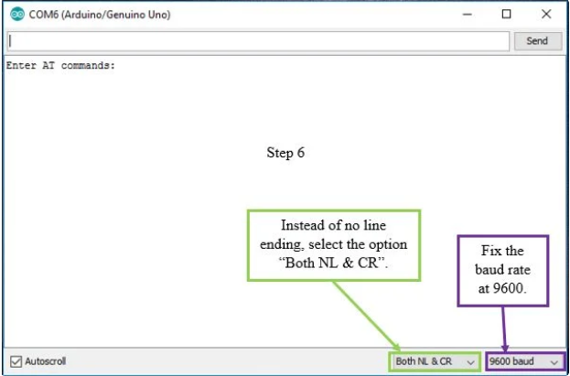

Now enter AT and press enter. It should say OK. Next enter AT+ROLE=0. Now, enter AT+ROLE? and it should show that role is 0 (slave). Next enter AT+ADDR? and it will return the address. Copy the address and save in somewhere (change the colons to commas on the address). Now connect the other module similarly and repeat the same steps. This time set AT+ROLE=1, for master. Set AT+CMODE=0 (which means it will pair with only one device). Next call AT+BIND=(address), so that the master module is paired with our slave module. Here’s a detailed video on how to do these steps:

<https://www.youtube.com/watch?v=BXXAcFOTnBo>

**Schematic:**

**Bluetooth controller:**

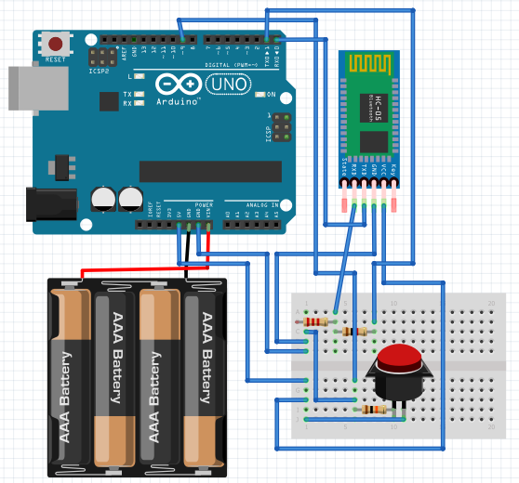

**Motor:**

